Cracow

GENERAL INFORMATION
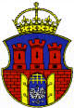
Population: | 759131
Province: | Lesser Poland
Telephone: | +48 12
Museums: | 44
Districts: | 18
Theatres: | 26
Mayor: | Jacek Majchrowski
Higher Education: | 23

Krakow is situated in a valley formed by the Vistula River The oldest part of Krakow lies on the northern (left) bank of the river.
Krakow is the capital of Malopolska (Lesser Poland), The region is a popular tourist destination, and along with magnificent Krakow there is also Zakopane, Wieliczka, Krynica, Niedzica, and Oswiecim to be visited. Zakopane lies in the Tatra Mountains (the highest in Poland), but there are also the Pieniny and Beskid Mountains to choose from.
Krakow is Poland’s second largest city (over 755,000 people). The city is known as the most popular tourist destination in Poland, with the former royal Wawel castle. The majority of monuments are situated in the Old Town, framed by the ring-shaped park, known as “Planty”. In the centre of the Old Town there is Europe's largest market square, with the “Sukiennice” (the Cloth Hall) dating from the 14th century and one of the best-known landmarks of Krakow.

Wawel is home to three dynasties of Poland's monarchs. Its stately halls and exquisite chambers are filled with priceless art, best period furniture and ancient objects.
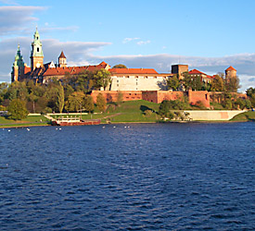

The Basilica of the Virgin Mary’s is the immense Gothic church, Krakow's principal temple since the 13th century, It seems to be the most famous of all Poland's churches.

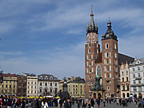

After an archaeological find discovered and excavated underground tunnels under Krakow´s Main Market Square in 2005, the much publicised Rynek Underground Museum was created, opening its doors to the public for the first time in September 2010.
The multi hi-tech museum is subtitled, “In the Footsteps of Krakow´s European Identity” and plots the evolution of the city from its earliest settlements in 2000BCE to the death of Pope John Paul II in 2005.
Audio guides are available in several European languages. Space is limited to 300 visitors at any one time. It is best to book ahead and reserve your place to save disappointment.

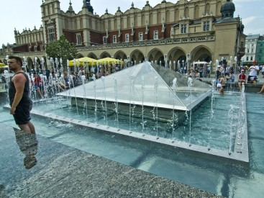

Sukiennice, or Cloth Hall is one of Krakow´s major tourist attractions. The Medieval Shopping Centre was built in 1257, but the original structure needed renovating after it was ravaged by fire in 1555.
Sukiennice is still an important centre at the heart of Krakow´s trade and industry, only these days the merchandise as moved with the times and is focused on souvenirs, handicrafts and amber jewellery.
Visitors will also find an art museum on the first floor exhibiting a collection of 19th Century sculptures and paintings.

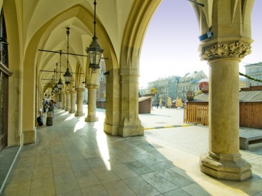

The Wieliczka Salt Mine (Polish: Kopalnia soli Wieliczka), lies within the Kraków metropolitan area. The mine, built in the 13th century, produced table salt continuously until 2007, as one of the world's oldest salt mines still in operation. From its beginning and throughout its existence, the Royal mine was run by the Żupy krakowskie Salt Mines. The mine's attractions include dozens of statues, three chapels and an entire cathedral that has been carved out of the rock salt by the miners. About 1.2 million people visit the Wieliczka Salt Mine annually.
The mine is one of Poland's official national Historic Monuments (Pomnik historii), as designated in the first round, September 16, 1994. Its listing is maintained by the National Heritage Board of Poland.
