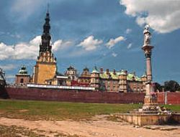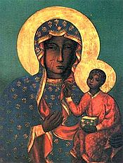
Częstochowa
It is a city in south Poland on the Warta River with the population of about 240,027 inhabitants. It is 13th most populous city in Poland. It is the largest economic, cultural and administrative hub in the northern part of Silesian Voivodship. Czestochowa plays a crucial role for the Roman Catholic Poles, because it is a kind of spiritual capital to them. The cult status of the Jasna Gora monastery, has been growing. It has become a symbolic mainstay of Polish identity and the Roman Catholic religion.
The number of pilgrims and tourists arriving to the city amounts to 5 million a year. It is the home of the Black Madonna painting a shrine to the Virgin Mary. Every year, millions of pilgrims from all over the world come to Częstochowa to see it.
