Warsaw 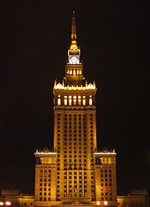
Warsaw is the capital and the largest city of Poland. It is located on the Vistula River, roughly 260 kilometres from the Baltic Sea and 300 kilometres from the Carpathian Mountains. Its population is estimated at 1.711 million residents within a greater metropolitan area of 2.666 million residents, making Warsaw the 9th most populous city proper in the European Union. The area of the city covers 516.9 square kilometers, while the city's agglomeration covers 6,100.43 square kilometers. Warsaw is known as the city of palaces, royal gardens and grand parks. Many aristocratic residences and mansions are located near the city center.
There are many interesting places to see there:

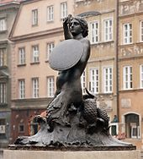The Mermaid Statue stands in the very centre of Old Town Square, surrounded by a fountain. This is not the only mermaid in Warsaw. Another is located on the bank of the Vistula River near Świętokrzyski Bridge and another on Karowa Street.
The origin of the legendary figure is not fully known. One of the legend says that a mermaid once swam to Warsaw from the Baltic Sea for the love of the Griffin, the ancient defender of the city, who was killed in a struggle against the Swedish invasions of the 17th century. The mermaid, wishing to avenge his death, took the position of defender of Warsaw, becoming the symbol of the city

Old Town
Walking the streets of the Old Town and New Town allows you to rest from the central city life. Atmospheric alleys, squares, and cosy cafés create a unique sense of history. In the summer, the Old and New Town Squares become stages for musical and theatrical performances and open-air galleries.
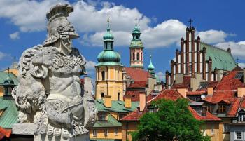

Park Palace Complex are the park and palace complex at Łazienki that are one of the most beautiful of this type in Europe. It was established in the 17th century. The landscape gardens feature many interesting architectural monuments, the most important of which include the Palace on the Island built for King Stanislaw August Poniatowski – Poland’s last monarch. It served as his summer residence and was famous for the Thursday dinners.
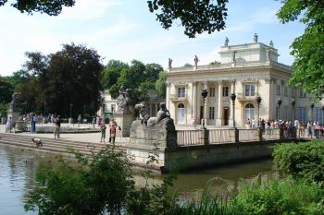

Wilanów Park-Palace Complex is the summer residence of King Jan III Sobieski and then Augustus II as well as subsequent aristocratic families. It is an excellent representation of European Baroque at its height. The palace is surrounded by a grandiose, two level Baroque Italian garden and a romantic park in English style. Wilanów is the venue of important cultural events and concerts. 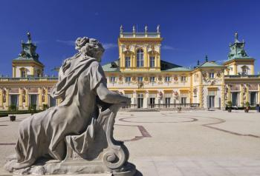

Palace of Culture and Science was completed in 1955 as a ‘gift from the Soviet people’, the building is the embodiment of Socialist Realist architecture. It is still the tallest building in Poland and fulfils the role of a cultural centre accommodating theatres, museums, a cinema and a concert hall. The highest viewing platform in Warsaw, on the 30th foor. It offers an excellent panoramic view of the city.
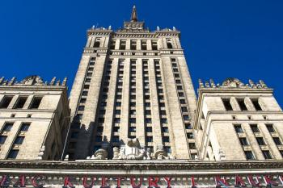

Copernicus Science Center is a kingdom of experiments and a heaven for those interested in the world. Here everyone can conduct experiments on their own and, above all, have fun.
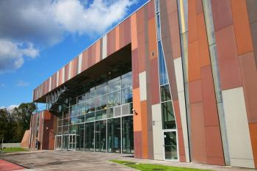

The National Stadium in Warsaw was built for the European Football Championship UEFA EURO 2012 in place of the former 10th-Anniversary Stadium. It is located close to the Old Town and city centre. It is well visible from many places in Warsaw. It is especially attractive from the side of the Zamkowy Square. A walk to the stadium from the Palace of Culture and Science takes less than 30 minutes.
